**As a UX Designer, I will approach the problem statement by following these steps:**

1. Research: I will conduct research to understand the problem and user needs. The research will include desk research, competitive analysis, user interviews, surveys, and user testing to identify pain points, user habits, and potential solutions. Inspiration will be drawn from existing fitness and wellness apps that have similar goals.

2. Information Architecture and User Flow: Based on the research, I will develop the information architecture and user flow to ensure that the app is user-friendly and easy to navigate. The user flow will guide the user from the landing page to the main features of the app, such as tracking physical activity, receiving reminders, and personalized progress monitoring.

3. Important Feature Sets: The app primary focus will be on physical activity, and important feature sets will include tracking physical activity, setting reminders, personalized progress monitoring, gamification elements, social features, and health expert collaboration. The reason for these feature sets is to ensure the user is motivated and supported throughout their fitness journey, making the app more engaging and effective.

4. Wireframes: I will design end-to-end wireframes for two essential feature sets tracking physical activity and personalized progress monitoring.

a. Tracking Physical Activity: The user will be able to track their physical activity through a gamified interface that encourages the user to move more throughout the day. The user will be able to set their daily goals and track their progress in real-time. The wireframe will show different types of physical activities, such as walking, running, and cycling, with an option to choose the activity and duration.

b. Personalized Progress Monitoring: The user will be able to monitor their progress with personalized metrics such as calorie burn, steps taken, and distance travelled. wireframe will show personalized charts and graphs that display the user progress over time, and users will receive motivational feedback to keep them motivated.

5. Presentation: I will create a presentation that articulates the research, the thought process behind the wireframes, and how the app feature sets address the problem statement. The presentation will also highlight the app USP and how it will benefit users by promoting healthy habits and preventing adverse effects of prolonged sitting. Overall, the app aims to encourage physical activity and promote healthy habits, thus improving the overall well-being of its users.

**Architecture and User Flow**

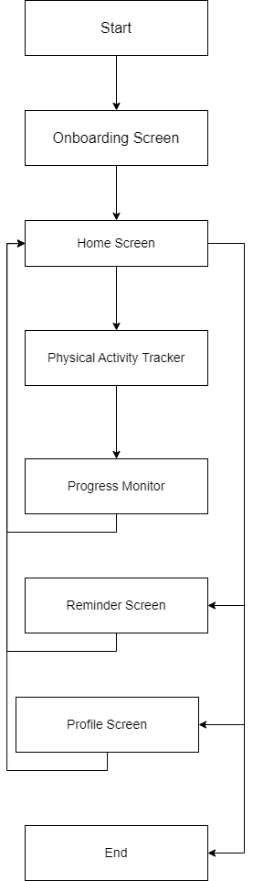

**Wireframes for an application**

Based on the problem statement, here are the wireframes for an application that aims to create awareness and enable better habits to tackle a sedentary lifestyle:

1. Onboarding Screen: Upon opening the app, the user will see an onboarding screen with

a welcome message, a brief description of the app, and a call-to-action button to proceed

to the next screen.

2. Home Screen: The Home screen will have the following elements:

• A motivational quote or tip to start the day

• A progress tracker to show the user daily activity level

• A list of suggested activities that the user can do at home or during breaks

• A quick-action button to start a physical activity or to set a reminder to move

• A health expert corner that provides useful tips and advice for better health

• A social feature that allows users to connect with friends and other users to share progress and get support

3. Physical Activity Tracker: The Physical Activity Tracker screen will allow the user to track

their physical activity in different forms. It will include:

• A gamified interface that encourages the user to move more throughout the day

• An option to choose the activity and duration from a list of pre-defined activities

• A progress bar that shows the user progress towards their daily goal

• Feedback and motivational messages to keep the user engaged

4. Reminder Screen: The Reminder screen will allow the user to set reminders to move

throughout the day. It will include:

• An option to set reminders at fixed intervals, such as every hour or every 30 minutes

• An option to customize the reminder frequency and message

• A snooze button in case the user is unable to move at the scheduled time

• An option to turn off reminders if they are not required

5. Progress Monitor: The Progress Monitor screen will allow the user to monitor their progress over time. It will include:

• Personalized charts and graphs that display the user progress over time

• Metrics such as calorie burn, steps taken, and distance travelled

• A comparison with their past performance to help users gauge their progress

• Feedback and motivational messages to keep users motivated

6. Profile Screen: The Profile screen will allow the user to manage their profile settings. It

will include:

• An option to update personal information and profile picture

• An option to connect with friends and other users

• Settings to customize the app notifications and reminders

• An option to log out of the app

These wireframes aim to create an engaging and intuitive user interface that encourages users

to develop healthy habits and prevent the adverse effects of prolonged sitting.

